# PowerApps Application Profile and Details

## Employee Engagement

**What is this application about?**

With the Employee Management Power App, HR administrators can easily input and update employee information, including.

1. Personal details

2. Contact information

3. Job specifics

4. Departmental information

**Objective:**

* The objective is to leverage the power of technology to boost productivity and efficiency in a quantifiable way.
* The application provides a centralized database where HR personnel can efficiently manage employee records, ensuring that the information is accurate, up-to-date, and easily accessible.
* It also includes robust security features to ensure that employee data is protected and accessible only to authorized personnel.

**Architecture Diagram**

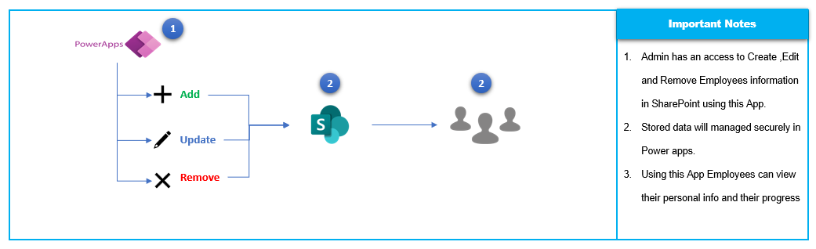

**Data source & Important Functions Used**

**1. Data Source:**

**SharePoint -** SharePoint is our primary data source where the employee details are managed.

**2. Important Functions Used:**

Admin and User Recognition Functionality Implemented.

**Benefits to the User**

It incorporates role-based access controls, ensuring that HR administrators have the necessary permissions to create, view, and edit employee records, while employees can only access their own data.

**Alternate to Application**

* Culture Amp
* 15Five
* OfficeVibe
* TinyPulse
* Enboarder
* Trivia
* iCIMS Onboard

## Time and Attendance Tracker

**What is this application about?**

* Time tracking software is a tool used by managers and employees to record worked hours for billing, payroll or operations.
* In general, they capture time spent on assigned tasks and used to automate payroll or client invoicing.
* They can also provide insights on your operations, such as, which tasks are taking a lot of your staff’s time and costing the most money, allowing users to plan project budgets.

**Objective:**

* Benefits of Time Tracking Software,
  + - Increase productivity
    - Effortless time capture
    - Promote workplace transparency
    - Improve accuracy of your deadlines
    - Empower employees
* The time and task tracking functionality allows employees to record their working hours, log their tasks, and track the progress of assigned projects.

**Architecture Diagram**

**Data source & Important Functions Used**

**1. Data Source:**

**SharePoint -** SharePoint is our primary data source where the Time Tracking and Timesheet details are managed.

**2. Important Functions Used:**

**Benefits to the User**

* It provides a centralized platform for project managers to monitor project timelines, allocate resources, and ensure project deliverables are met.
* Additionally, the system captures attendance records, enabling managers to track employee attendance patterns and make informed decisions regarding workforce management.

**Alternate to Application**

* Toggl Track
* HourStack
* Timely
* TrackingTime
* RescueTime
* Time Doctor
* Clockify
* TimeCamp
* Paymo
* MyHours

## Leave Request Portal

**What is this application about?**

* Managing employee time off requests can be a headache for both the one submitting the request as well as the one approving.
* You can apply for half-day leave, one-day leave, sick leave, emergency leave, maternity leave, paternity leave, casual leave, vacation leave and annual leave.

**Objective**

* Submit leave requests
  + - Requests are routed to a user’s manager. This is determined by populating the Manager field in Management Table.
* Notifications
  + - When a request is submitted, the manager receives an email with the pertinent details.
    - When the status of a request changes (approved or declined), the user who submitted this request receives an email with the information.
* View past and future leave requests
  + - These are sorted by pending, approved, and declined requests.

**Architecture Diagram**

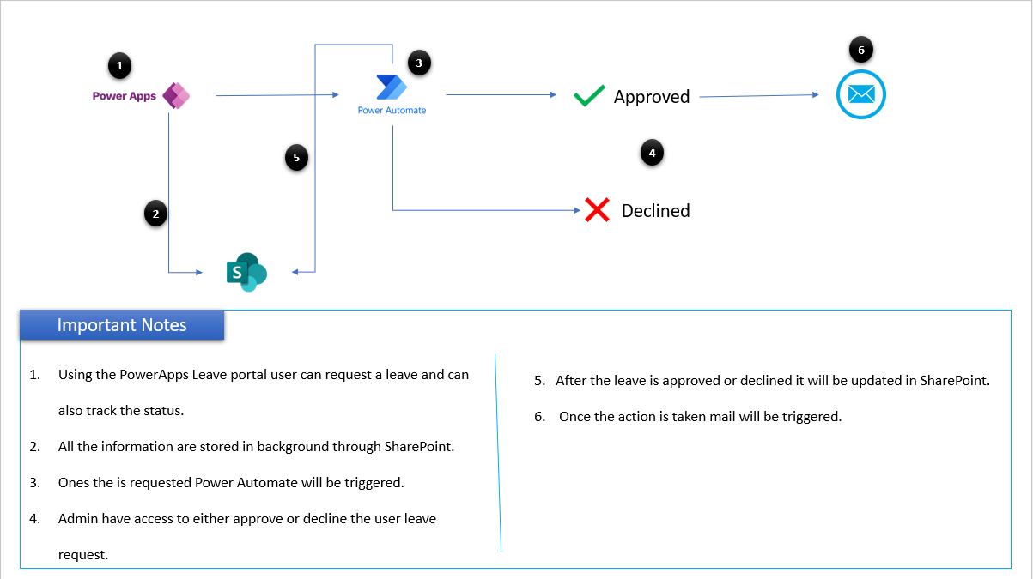

**Data source & Important Functions Used**

**1. Data Source:**

**SharePoint -** SharePoint is our primary data source where the leave details are managed.

**2. Important Functions Used:**

* Admin, Manager and User Recognition Functionality Implemented.
* Dynamic UI change system depends on user access.
* Leave Approval and E – mail trigger system implemented.
* Leave tracking system implemented.

**Benefits to the User**

* The Leave Request Power App simplifies and streamlines the process of requesting and approving leave.
* By providing employees with an easy-to-use interface to submit and track their leave requests and offering reporting managers a convenient platform to review and approve requests.
* This application enhances transparency, reduces administrative burden, and improves overall efficiency in managing leave within the organization.

**Alternate to Application**

* Kissflow HR Cloud
* Pocket HCM
* ADP
* GreytHR
* Workforce
* Calamari
* LeaveBoard
* Timetastic
* PlanMyLeave
* WhosOff
* Built for Teams

## Skill Management

**What is this application about?**

* Skills management software can help you with an assortment of tasks, from making it easy to track employee training sessions to managing your organization’s ongoing skill improvement initiatives.
* It helps keep employees and employers up to date on the latest trends in industry standards, enabling both parties to make as efficient and cost-effective decisions as possible.

**Objective**

* Skills management software is a crucial tool for any company that has many employees. It helps to organize your company’s skills, assists in the hiring process, and can help you find suitable candidates based on their qualifications and skill set.
* It provides a centralized database to store and update employee skill sets, certifications, and training records.
* This feature helps in identifying the right individuals for specific projects or tasks and ensures efficient resource allocation.

**Architecture Diagram**

**Data source & Important Functions Used**

**1. Data Source:**

**SharePoint -** SharePoint is our primary data source where the employee skillset and certification details are managed.

**2. Important Functions Used:**

**Benefits to the User**

Organization might do with this system include,

* Updating performance reviews
* Administering promotions and appraisals
* Identifying skill gaps in its workforce to serve customers better
* Managing job-specific competencies with mobile-ready digital certifications

**Alternate to Application**

* Pluralsight Skills
* Growthspace
* Juno Journey
* Cloud Academy
* Cinode
* Neobrain
* iMocha
* Nestor
* 365Talents
* Skills Base
* AG5 Skills Management Software
* Skillnet
* Gloat
* CompetencyCore
* TalentQuest
* MuchSkills

## Performance Management

**What is this application about?**

* Performance management tools are software applications that track productivity on an individual, team or organizational level.
* They typically measure, gather, and organize data and present it in a central location so business leaders can assess the data, gain valuable insights, and make informed business decisions.

**Objective**

* Performance management is another critical aspect of the Power Apps.
* It enables organizations to set performance goals, conduct regular reviews, and provide feedback to employees.
* The module tracks performance metrics and generates comprehensive reports, allowing managers to make informed decisions regarding performance appraisals, talent development, and career advancement.

**Architecture Diagram**

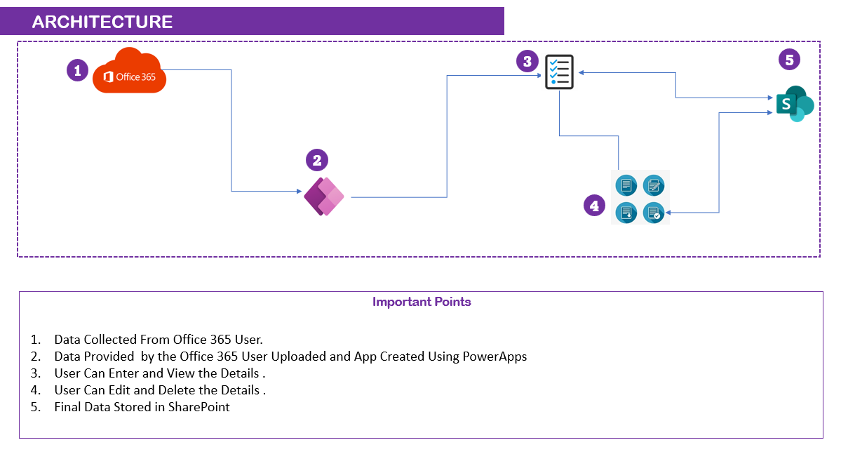

**Data source & Important Functions Used**

**1. Data Source:**

**SharePoint -** SharePoint is our primary data source where the employee goals and performance details are managed.

**2. Important Functions Used:**

* Implemented role level access securing using office 365.
* Dynamic Organization Chart access implemented to view reporters’ information.

**Benefits to the User**

* Supervisors, human resources managers and other team leaders can use these kinds of tools to delegate tasks appropriately, provide better training resources to teams and guide employees to achieve goals.
* Well-performing team members can improve the overall performance of a business, helping to attract clients and earn profits.

**Alternate to Application**

* Reflektive
* Workhuman Conversations
* Bamboo HR
* BerniePortal
* Leapsome
* AssessTEAM
* ClearCompany
* ToDoist
* PerformYard

## Internal Ticketing system

**What is this application about?**

* A Internal ticketing system manages support inquiries that are filed within a company.
* When employees have issues with their tools, they'll report their cases via the Internal ticketing system.
* The software then creates a digital record of the inquiry and notifies an IT professional for assistance.

**Objective**

* Internal ticketing systems formalized your internal support process.
* It makes it easier to keep track of open cases which reduces the time that your employees must wait to get their issues resolved.

**Architecture Diagram**

**Data source & Important Functions Used**

**1. Data Source:**

**SharePoint -** SharePoint is our primary data source where the issue ticket details are managed.

**2. Important Functions Used:**

* Admin and User Recognition Functionality Implemented.
* Email triggering system using Power Automate.
* Dynamic UI change system depends on user access.

**Benefits to the User**

* Using Internal ticketing system, IT employees are automatically notified whenever a case is created. Your employees don't have to physically make their way to the IT department whenever something breaks.
* They can simply file a new ticket and receive a response from an internal employee almost immediately.
* This reduces any friction that can occur when employees are stacked against deadlines and need to work with your IT team to find a speedy resolution.

**Alternate to Application**

* HubSpot Help Desk and Ticketing Software
* Intercom
* Solarwinds
* HappyFox
* ProProfs Help Desk
* Jira Service Desk
* Mojo IT Helpdesk
* Freshservice
* Zendesk
* Vision Helpdesk
* Zoho Desk
* ServiceDesk Plus
* Jitbit
* Hiver

## E-commerce application

**What is this application about?**

* E-commerce app is a stand-alone program or software suite that enables you to sell your products and services online.
* It allows you to streamline all your processes from inventory to sales through the backend and makes it easy for a customer to buy from the front end, which is your app.

**Objective**

* E-commerce software is important for your business because it helps you expand your sales beyond brick-and-mortar.
* You can have a physical store or office and sell your products or services online through an e-commerce site to reach more buyers.

**Architecture Diagram**

**Data source & Important Functions Used**

**1. Data Source:**

**SharePoint -** SharePoint is our primary data source where the Purchase and Client details are Securely managed.

**2. Important Functions Used:**

PDF generation with Mail attachment system implemented using Power Automate.

**Benefits to the User**

* E-commerce service also helps you gain access to selling and marketing tools that help raise awareness of your business.
* Easily create an online business.
* Improve efficiency.
* Boost revenue.
* Increase customer satisfaction.
* Reacher broader audiences.
* Save money and resources.
* Accept more payment options.

**Alternate to Application**

* Shopify
* Wix
* BigCommerce
* Adobe Commerce
* WooCommerce
* PrestaShop
* Squarespace
* GoDaddy
* Volusion
* Amazon
* Shift4Shop

## NAAC Application

**What is this application about?**

* The NAAC application refers to the process through which educational institutions apply for accreditation by the NAAC.
* Accreditation is a quality assurance process that evaluates the overall performance of an institution in terms of its educational practices, infrastructure, governance, and other relevant parameters.

**Objective**

The primary objectives of the NAAC application are as follows:

**Quality Assurance:** The application aims to ensure and enhance the quality of higher education by evaluating institutions against established standards and benchmarks.

**Accreditation:** The NAAC application process helps institutions obtain accreditation, which is a recognition of their quality and adherence to specified standards. Accreditation serves as an assurance to students, parents, employers, and other stakeholders about the quality of education provided by the institution.

**Continuous Improvement:** The application process encourages institutions to identify their strengths, weaknesses, and areas for improvement. It helps institutions develop a culture of continuous quality enhancement and provides them with valuable feedback for further development.

**Transparency and Accountability:** The NAAC application process promotes transparency and accountability in higher education institutions by providing an objective and standardized assessment framework. It ensures that institutions are evaluated based on predetermined criteria and parameters, fostering a fair and unbiased evaluation process.

**Benchmarking:** The application process allows institutions to benchmark themselves against national and international standards of excellence in higher education. It provides institutions with an opportunity to compare their performance and practices with other institutions, facilitating learning from best practices.

**Institutional Development:** The NAAC application aims to contribute to the overall development and improvement of educational institutions. Through the application process, institutions receive feedback, recommendations, and guidelines for enhancing their teaching-learning processes, infrastructure, research culture, and governance.

**Architecture Diagram**

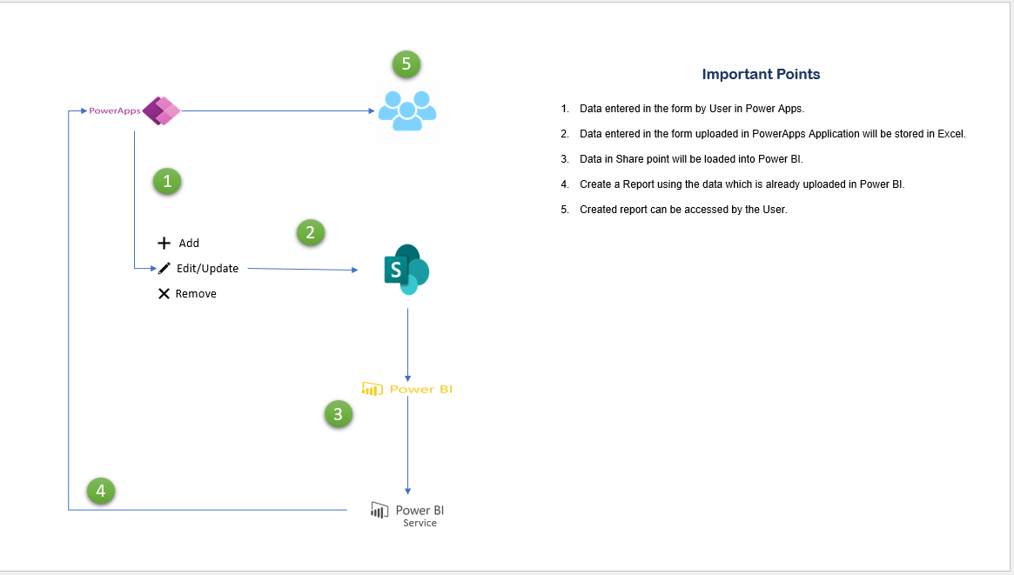

**Data source & Important Functions Used**

**1. Data Source:**

**SharePoint -** SharePoint is our primary data source where the NAAC details are managed.

**2. Important Functions Used:**

* Department level access Recognition Functionality Implemented.
* Text Recognition Functionality has been Implemented.

**Benefits to the User**

* Using this app University can check whether they are eligible or not.
* It saves the cost of applying if they are not eligible.

**Alternate to Application**

NAAC App

## JIRA Application

**What is this application about?**

* JIRA provides a centralized platform for managing tasks, bugs, and other types of issues and it helps teams to organize and prioritize their work.
* Additionally, JIRA also provides various reporting and dashboard features that help teams to stay on top of their work and make data-driven decisions.

**Objective**

* There are several different issue types in JIRA that can be used to categorize and organize work items. Some common issue types include,
  + - New Development - Assigning Requirements or Project to lead.
    - Bug - A problem with the software that needs to be fixed.
    - Enhancement - Enhancing the existing project.
    - Support - Requesting a support from specific team or person.
* JIRA administrators can customize the issue types in their instance of JIRA to match their specific needs and processes. For example, they can add new issue types, rename existing issue types, or change the fields and workflows associated with each issue type.

**Architecture Diagram**

**Data source & Important Functions Used**

**1. Data Source:**

**SharePoint -** SharePoint is our primary data source where the ticket details are managed.

**2. Important Functions Used:**

* Role level access implemented.
* Status tracking functionality implemented.

**Benefits to the User**

* It helps project managers and teams plan projects more effectively.
* Thanks to its status tracking, you can always keep track of progress.
* Assigning tasks and the ability to leave comments also makes it easier for remote teams to work together.
* Another reason to use Jira is its high flexibility and customizability.

**Alternate to Application**

* ClickUp
* Binfire
* Basecamp
* Pivotal Tracker
* Asana
* Shortcut
* Trello
* ProofHub
* Kanbanize
* Notion
* Wrike
* Bitrix24
* Backlog

## CRM Application

**What is this application about?**